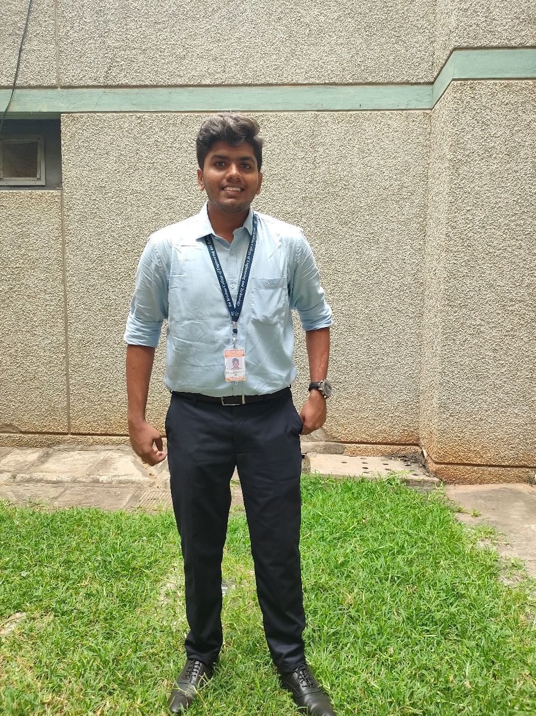 ACHYUTH R

**Software Development Associate**

Gmail: [achyuth2511@gmail.com](mailto:achyuth2511@gmail.com) || GitHub: <https://github.com/achu2511>|| LinkedIn : https://www.linkedin.com/in/achyuth-r-9b31b9240 || Phone Number : +91 6381552723 || Current City: Coimbatore || Home city : Hosur

# Skills:

* **Experienced :** Java , Spring Services, React JS
* **Intermediate :** SQL , CI/CD deployment, Python, C/C++ ,PostgreSQL
* **Familiar :** Mongo DB, Machine Learning, NLP
* **Other :** Proficiently conveying complex ideas during hackathons, ensuring all members understand the problem statements and the tasks to be performed . The ability to think critically and solve problems.

# Education:

**Undergraduate (UG):** Pursuing Artificial Intelligence and Data Science at Sri Krishna College of Engineering and Technology, Coimbatore. [2021-2025] **Current CGPA**: 8.59.

**High School:**

* Completed 12th grade at Maharishi Vidya Mandir, Hosur [CBSE 2021]. **12th Grade:** 93.2%.
* Completed 10th grade at Maharishi Vidya Mandir, Hosur [CBSE 2019]. **10th Grade:** 86%.

# Projects:

## Ink Mimic - AI-Powered Writing Style Replication

* **AI-Powered Style Replication:** Created an innovative solution that uses AI to reproduce the distinct writing styles of many authors.
* **User-Friendly Interface:** Created a simple and easy interface that allows users to enter text and choose their preferred author, as well as customize choices for style imitation.
* **Customization and Accuracy:** Users can now fine-tune style settings, resulting in excellent accuracy in duplicating tone, sentence structure, and literary devices. Used Mistral 7B LLM Model and Fine tuned it.
* **Tech Stacks used: Frontend**: React JS ,CSS , **Backend**: Flask , Python, Fast Api , **Database**: Mongo DB.

**Real-Time Stock Price Tracker in Python**

* Developed a **Python real-time stock price tracker** by utilising pandas, Beautiful Soup, and requests modules.
* **Asynchronous programming** techniques and **multithreading** were used to guarantee timely and **effective stock price updates**.
* Built an **intuitive user interface** that enables users to **watch many stocks at once and configure price threshold alerts**.

## Gardening Store E-commerce Platform

* The Gardening Store platform was built **using Spring services and React JS**, elegantly integrating technology and gardening comfortably.
* Using Spring Java, we implemented **OOP concepts, JWT Security, and a secure payment gateway**, resulting in a robust and safe e-commerce experience.

# Achievements:

* Secured First Prize in Vision AI Hackathon conducted by Sri Krishna College of Engineering and Technology.
* Qualified for finals of Pragati Hackathon conducted by iHub Drishti ,IIT Jodhpur [on DEC 8 – 10 at IIT,Jodhpur]
* Qualified for Finals of TRI-NIT hackathon conducted by NIT Trichy. [online]

# Courses And Certifications:

**NPTEL ->** Organizational Behaviour

**AWS ->** Academy Graduate -AWS Academy Cloud Foundations

**Infosys Spring Board - >** Selenium: Using Selenium for Continuous Testing

**L&T EduTech->** MongoDB Basics For Beginners Part 1 & 2